Liste de prix pour vos produits d’entretien de lentilles de contact

 |  | Prix public | Prix Privilège | Prix / 1 ml | Quantité
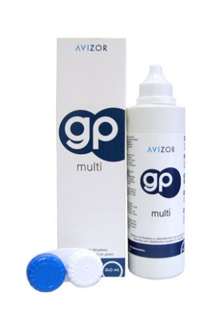 | Avizor GP Multi  240 ml | 21.50 | 19.00 | 0.079 / 1ml
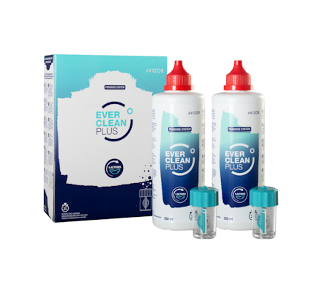 | Ever Clean Plus  2 x 350ml | 65.00 | 60.00 | 0.08 / 1ml
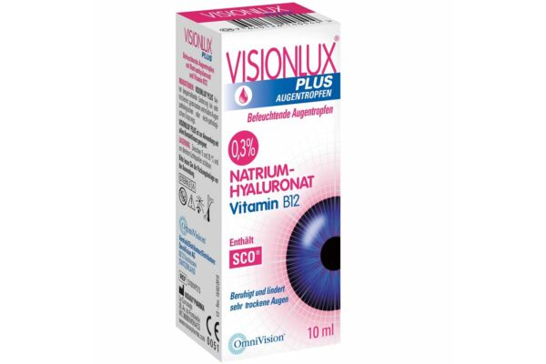 | Visionlux  10ml | 15.00 | 14.00 | 1.4 / 1ml
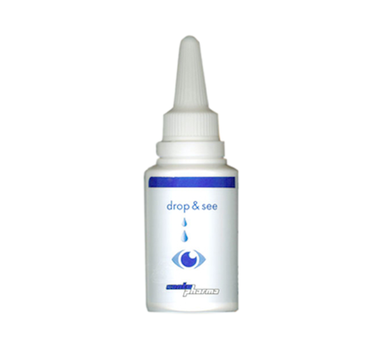 | Drop&See  25ml | 18.20 | 16.00 | 0.64 / ml
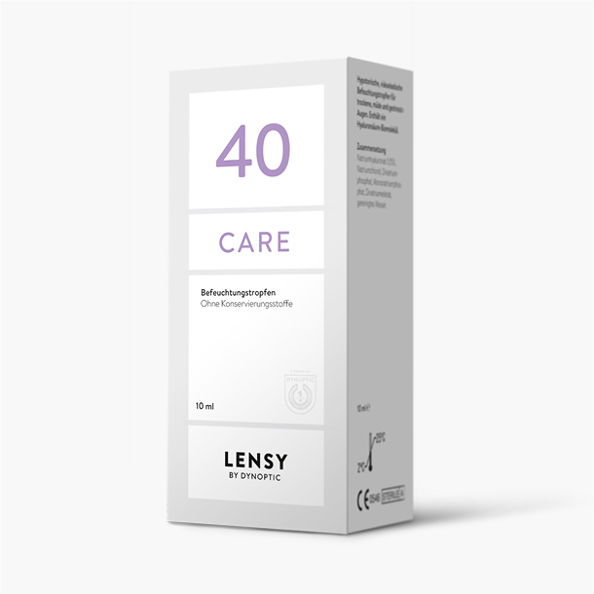 | Lensy Care 40  10ml | 1 x | 19.00 | 0.52 / 1ml
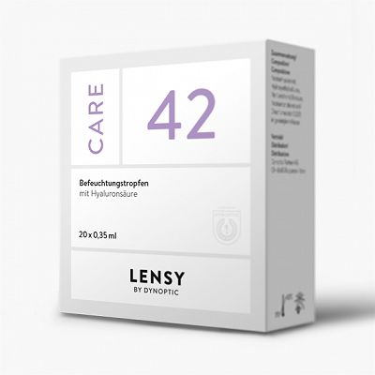 | Lensy Care 42  20x 0.35 ml | 1 x | 15.00 | 2.14 / 1ml
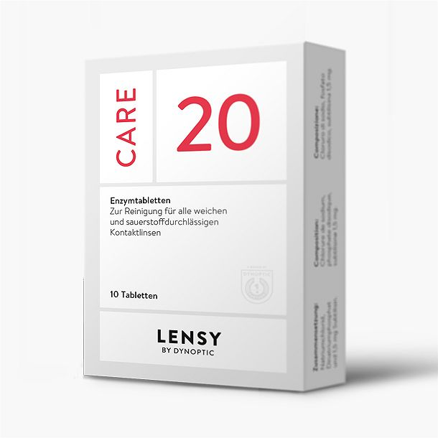 | Lensy Care 20  10 tab. | 1 x | 14.00 | 1.40 / 1tb
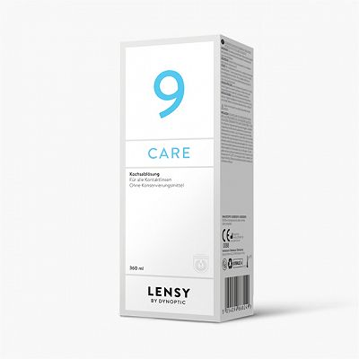 | Lensy Care 9 +  360 ml | 1 x(11.00)  2 x(22.00)  3 x(33.00) | 11.00  20.00  28.00 | 0.030 / 1ml  0.027 / 1ml  0.025 / 1ml
 | Lensy Care 9 +  100 ml | 1 x(6.00)  2 x(12.00)  3 x(18.00) | 6.00  10.00  14.00 | 0.06/ 1ml  0.05 /1ml  0.046 / 1ml
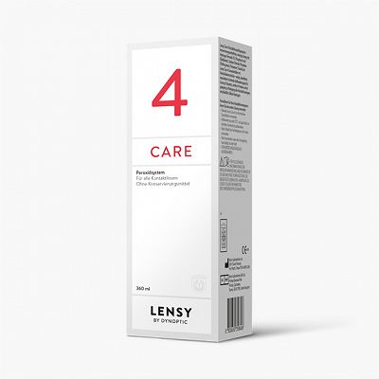 | Lensy Care 4  360 ml | 1 x(24.00)  3 x(72.00)  6 x(144.00) | 24.00  63.00  120.00 | 0.066 / 1ml  0.058 / 1ml  0.055 / 1ml
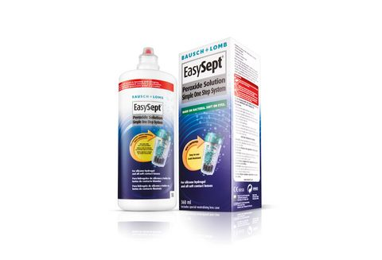 | EasySept DAS  360ml | 1x(27.90)  3x(83,70) | 1 x 25.00  3 x 70.00 | 0.069 / 1ml  0.064 / 1ml
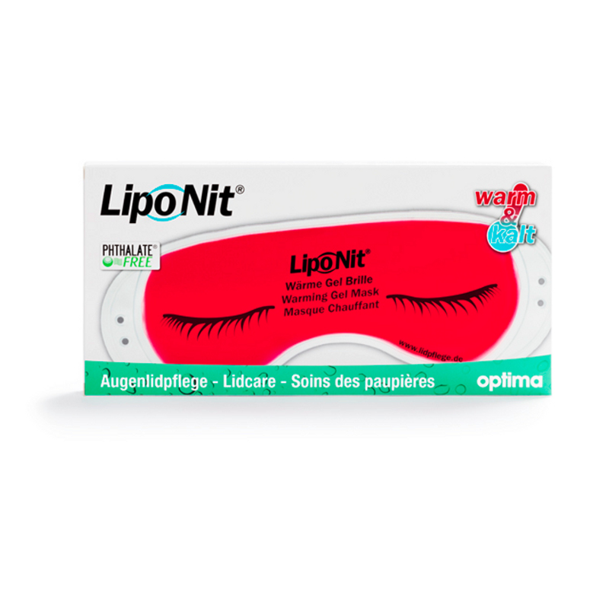 | Lipo Nit  Soins des paupières  1 masque | 12.00 | 12.00
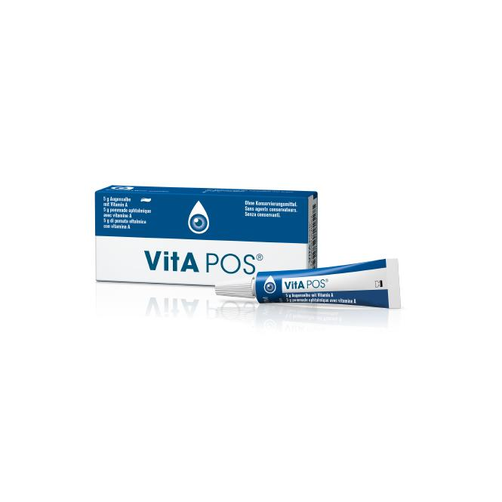 | VitA POS  5 g | 12.50 | 11.00 | 2.2 / g
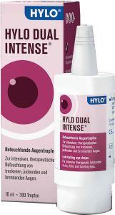 | Hylo-Dual Intense  10 ml | 29.00 | 27.00 | 2.70 / 1ml
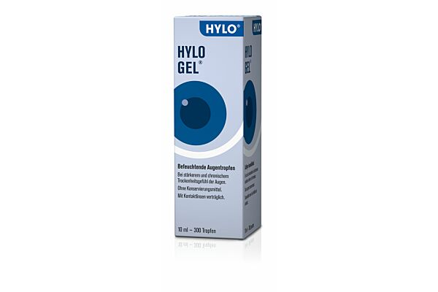 | Hylo-Gel 0.2%  10 ml | 29.80 | 27.00 | 2.70 / 1ml
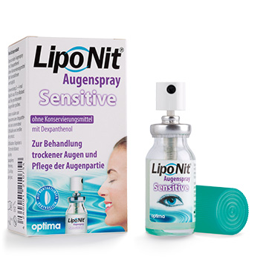 | Lipo Nit  Sensitive  10ml | 19.90 | 18.00 | 1.80 / 1ml
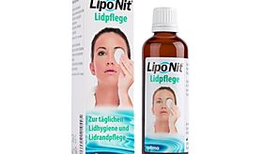 | Lipo Nit  Soin paupières  70 ml | 19.00 | 17.00 | 0.22 / 1ml
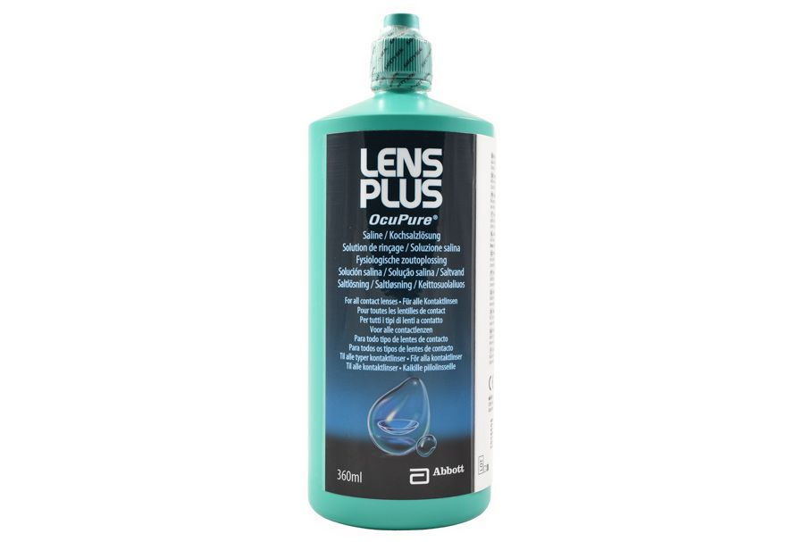 | Lens Plus Purit  360 ml | 16.50 | 14.00 | 0.039 / 1ml
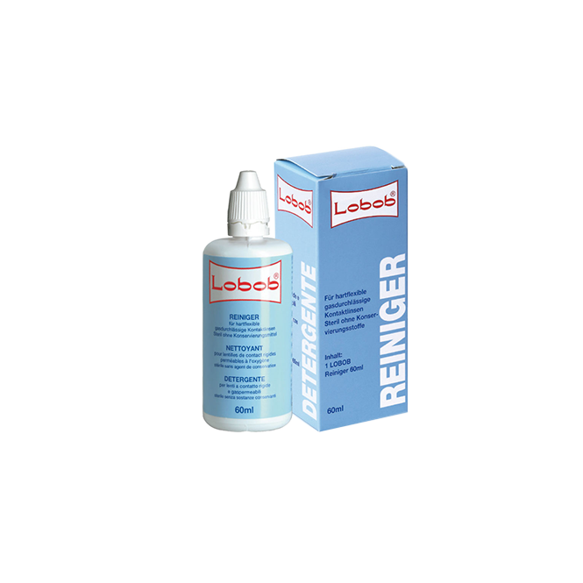 | Lobob  60 ml | 16.50 | 14.00 | 0.23 / 1ml
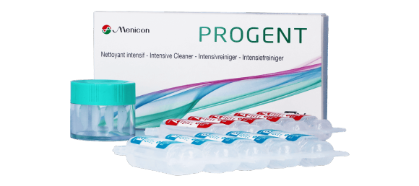 | Menicon  5 traitements + étui | 19.80 | 17.00 | -
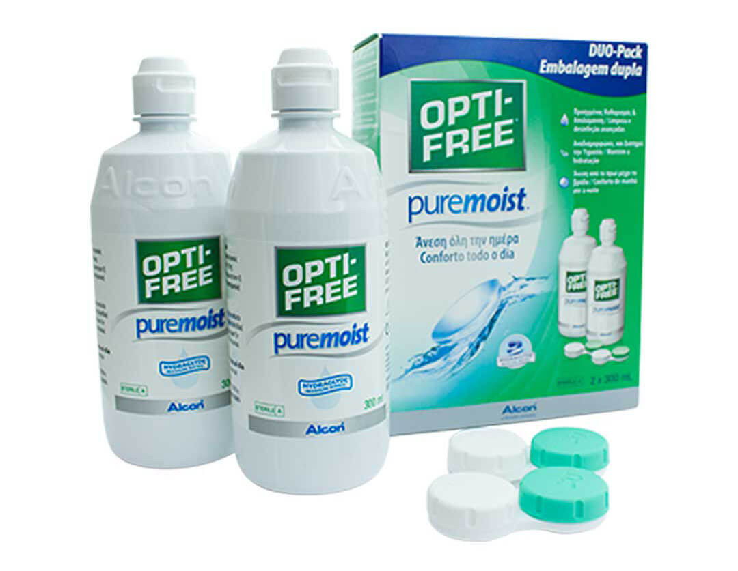 | Optifree Pure Moist  300 ml | 24.90 | 22.00 | 0.073 / 1ml
 | Optifree Pure Moist  Duo 2 X 300 ml | 43.00 | 38.00 | 0.063 / 1ml
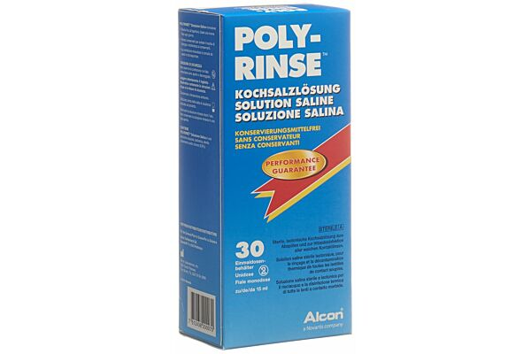 | Polyrinse  30x15 ml | 20.90 | 18.50 | 0.04 / 1ml

www.voirol.ch

Frais de port 10.-

